Appendices

Appendix A: Parameters used in model
 | Category | Description | References
Risks/Probabilities | Death from other causes | Nonparametric | UK Lifetables. [18]
Risks/Probabilities | Sensitivity and Specificity of TTE in detecting ABN | Jointly estimated from Dirichlet distribution  (FN, TP, TN, FP) =  (5, 87, 83, 159) | Table 2 of Providencia et al 2012 [6]
Risks/Probabilities | Proportion of patients with ABN | Beta(2.5, 22.5) for CHADS₂  Beta(0.5, 11.5) for CHA₂DS₂-VASc  (Both with prior of 0.5 added to both cell counts.) | Table 2 of Providencia et al 2012 [6]
Risks/Probabilities | Annual stroke risk by CHADS₂ score | Annual risks (95% Credible intervals) by CHADS₂ were reported as follows:  0.6% (0.5% to 0.7%) for CHADS₂=0  3.0% (2.9% to 3.2%) for CHADS₂=1  4.2% (4.0% to 4.4%) for CHADS₂=2  7.1% (6.7% to 7.5%) for CHADS₂=3  11.1% (10.4% to 11.8%) for CHADS₂=4 | Friberg 2012[21]
Risks/Probabilities | Annual stroke risk in those with ABN | In the initial study four out of 50 patients with identified ABN had a stroke. This was used to produce a mean stroke rate of 8.0% and bootstrapped 95% CrIs of 7.2% to 8.2% | Stroke Prevention 1988 [5]
Risks/Probabilities | Relative risk (RR) of stroke in patients receiving dabigatran. | Indirect comparison simulation approach. One thousand simulated values from a lognormal distribution representing the RR of warfarin compared with placebo were multiplied by 1000 simulated values from a lognormal distribution comparing dabigatran with warfarin, to produce 1000 estimates of the RR of dabigatran compared with placebo. Mean RRs and 95% CIs/CrIs are shown below:  Reported RR warfarin vs. placebo: 0.33 (0.24 to 0.45)  Reported RR dabigatran vs. warfarin: 0.66 (0.53 to 0.82)  Derived RR dabigatran vs. placebo: 0.22 (0.15 to 0.32) | Lip et al 2006 for RR of warfarin compared with placebo [22]  Eikelboom et al 2011 for RR of dabigatran compared with warfarin[14]
Risks/Probabilities | Annual major bleeding risk for patients receiving dabigatran | Stratified by age. Credible interval calculated using simulation approach. Annual risk reported separately for people under 75 years, and people aged 75 years or older. Credible intervals were calculated by assuming sample sizes of 3618 for people aged under 75 years and 2419 for people aged 75 years or older, then sampling repeatedly and taking the values 2.5% and 97.5% of the way along the distributions. The central estimates (95% CrIs) are as follows:  Under 75: 2.1% (1.7 to 2.6%)  75 and older: 5.1% (4.2% to 6.0%) | Eikelboom et al 2011 [14]
Risks/Probabilities | Relative risk (RR) of stroke in patients receiving warfarin | Reported RR warfarin vs. placebo: 0.33 (0.24 to 0.45) | Lip et al 2006 [22]
Risks/Probabilities | Annual major bleeding risk for patients receiving warfarin | Stratified by age. Credible interval calculated using simulation approach. Annual risk reported separately for people under 75 years, and people aged 75 years or older. Credible intervals were calculated by assuming sample sizes of 3618 for people aged under 75 years and 2419 for people aged 75 years or older, then sampling repeatedly and taking the values 2.5% and 97.5% of the way along the distributions. The central estimates (95% CrIs) are as follows:  Under 75: 3.4% (2.5 to 3.6%)  75 and older: 4.4% (3.6% to 5.2%) | Eikelboom et al 2011 [14]
Risks/Probabilities | Relative risk (RR) of stroke in patients receiving rivaroxaban | Indirect comparison simulation approach. One thousand simulated values from a lognormal distribution representing the RR of warfarin compared with placebo were multiplied by 1000 simulated values from a lognormal distribution comparing dabigatran with warfarin, to produce 1000 estimates of the RR of dabigatran compared with placebo. Mean RRs and 95% CIs/CrIs are shown below:  Reported RR warfarin vs. placebo: 0.33 (0.24 to 0.45)  Reported RR Rivaroxaban vs. warfarin: 0.88 (0.74 to 1.03)  Derived RR Rivaroxaban vs. placebo: 0.30 (0.20 to 0.41) | Lip et al 2006 for RR of warfarin compared with placebo [22]  Patel et al 2011 for RR of rivaroxaban compared with warfarin [23]
Risks/Probabilities | Annual major bleeding risk for patients receiving rivaroxaban | The annual risk of bleeding given rivaroxaban was estimated indirectly by combining estimates of the risk of bleed given warfarin compared with placebo with estimates of the risk of bleed given rivaroxiban compared with warfarin. The central estimates (95% CrIs) were estimated to be as follows:  Under 75: 3.2% (2.5% to 4.0%)  75 or older: 4.6% (3.6% to 5.7%) | Eikelboom et al 2011 [14]  Patel et al 2011 [23]
Risks/Probabilities | Outcome following stroke | Simulation & mapping based approach described in an upcoming report.  The proportion dying of a stroke (95% CrI) was estimated to be 0.25 (0.23 to 0.27); the proportion in an independent state was estimated to be 0.56 (0.52 to 0.59); and the proportion in an dependent state following a stroke was estimated to be 0.19 (0.16 to 0.23). | Method described in report using results published in Rivero-Arias et al 2010 [24]
Risks/Probabilities | Outcome following a major bleeding event | Previous estimates. | Simpson et al 2010 [25]
Utilities | Baseline utilities by age and gender | Regression based approach, described in full in the reference. HRQoL is estimated as a function of age and gender, using the equation for the general population. | Ara et al 2010 [26]
Utilities | Utility multiplier following stroke, utility multiplier following major non-fatal intracranial bleed | Simulation & mapping based approach described in an upcoming report.  Utility multipliers (95% CrIs) were estimated to be 0.822 (0.819 to 0.824) for an independent state following a stroke, and 0.482 (0.477 to 0.487) for a dependent state following a stroke. | Method described in report results published in  Rivero-Arias et al 2010 [24]  See Table 2 for assumed mapping between Glasgow Outcome Scale (GOS) states and modified Rankin Scale (mRS) scores, and estimated utility multipliers associated with each state.
Costs | Annual cost of dabigatran | £920. A fixed cost was assumed. | NICE FAD, 2011 [27]
Costs | Annual cost of rivaroxaban | £767. A fixed cost was assumed. | London New Drugs Group [28]
Costs | Annual cost of warfarin | £252 to £259 including monitoring costs. A uniform distribution was assumed. | BNF [29]
Costs | Cost of TTE | £66 | NHS Reference Costs [19]
Costs | Cost of death due to stroke | £7,019 (95% CrI £6,975 to £7,064) | Sandercock et al 2002 [30]
Costs | Costs in stroke survivors | Various. Differing according to dependent and independent states. Subdivided into one-off and continuing costs. Estimates (95% CrIs) are as follows:  Dependent stroke, one-off costs: £2830 (£2708 to £2952)  Dependent stroke, continuing annual cost: £6386 (£5749 to £7023)  Independent stroke, one-off costs: £542 (£513 to £571)  Independent stroke, continuing annual cost: £3195 (£2871 to £3518) | NHS Reference Costs [19]  NHS Stroke Strategy Impact Assessment [31]  Unit Costs of Health and Social Care 2010 [32]
Costs | Costs of fatal bleed | Assumed identical to costs of death due to stroke
Costs | Costs of nonfatal bleed | Major bleeds subdivided into gastrointestinal (GI) and intracranial (IC). GI bleeds were assumed to incur a one-off cost but no continuing costs. The one-off cost (95% CrI) was £1261 (£1212 to £1310).  For IC bleeds, the costs depended on the Glasgow Outcome Scale (GOS) level of disability that they cause, from GOS 2 (most severe) to GOS 5 (least severe).  The one-off costs (95% CrIs) used were as follows:  GOS 2: £46785 (£40895 to £53250)  GOS 3: £10096 (£8849 to £11363)  GOS 4: £27419 (£22582 to £32964)  GOS 5: £1261 (£1211 to £1309)  GOS 4 and GOS 5 states were assumed not to have ongoing costs. The ongoing annual costs (95% CrIs) of the other states were as follows:  GOS 2: £50047 (£49645 to £50343)  GOS 3: £33949 (£33843 to £33969) | NHS Reference Costs [19]
Table 1 Parameters used in model

GOS state | Assumed equivalent to | Utility multiplier
GOS 2: vegetative state | mRS 6: dead | 0
GOS 3: severely disabled | mRS 4: moderately severely disabled; and mRS 5: severely disabled | 0.226 (95% CI 0.221 to 0.231)
GOS 4: moderately disabled | mRS 2: slight disability  and  mRS 3: moderate disability | 0.642 (95% CI 0.638 to 0.645)
GOS 5: good recovery | mRS 0: no symptoms  and  mRS 1: no significant disability | 0.895 (95% CI 0.892 to 0.898)
Table 2 Assumed relationship between GOS and mRS, and estimated utility multipliers for each GOS state

Appendix B: Sensitivity and Specificity tables
The tables below show how the mean ICER of the TTE compared with the No TTE strategy varies for each of 121 joint configurations of TTE sensitivity and specificity. D indicates that the TTE strategy is dominated by the No TTE strategy. Numbers show the ICER to the nearest £1000 (i.e. 19.2 refers to an ICER of £19 200/QALY). The code in the top left of each table refers to the patient population and OAC strategy under evaluation. (For example, W_65_0_M refers to 65 year old males with warfarin as the OAC of choice.)
- W_50
Specificity
0_M |  | 0 | 0.1 | 0.2 | 0.3 | 0.4 | 0.5 | 0.6 | 0.7 | 0.8 | 0.9 | 1
Sensitivity | 0 | D | D | D | D | D | D | D | D | D | D | ∞
Sensitivity | 0.1 | D | D | D | D | D | D | D | D | D | D | 8.4
Sensitivity | 0.2 | D | D | D | D | D | D | D | D | D | D | 5.7
Sensitivity | 0.3 | D | D | D | D | D | D | D | D | D | 70.7 | 4.9
Sensitivity | 0.4 | D | D | D | D | D | D | D | D | D | 26.2 | 4.4
Sensitivity | 0.5 | D | D | D | D | D | D | D | D | >99 | 17.1 | 4.2
Sensitivity | 0.6 | D | D | D | D | D | D | D | D | 65.6 | 13.1 | 4.0
Sensitivity | 0.7 | D | D | D | D | D | D | D | D | 35.0 | 10.9 | 3.8
Sensitivity | 0.8 | D | D | D | D | D | D | D | >99 | 24.5 | 9.5 | 3.8
Sensitivity | 0.9 | D | D | D | D | D | D | D | 63.9 | 19.2 | 8.5 | 3.7
Sensitivity | 1 | D | D | D | D | D | D | >99 | 40.2 | 16.0 | 7.8 | 3.6

- W_50_0_M
W_65 |  | Specificity
0_M |  | 0 | 0.1 | 0.2 | 0.3 | 0.4 | 0.5 | 0.6 | 0.7 | 0.8 | 0.9 | 1
Sensitivity | 0 | D | D | D | D | D | D | D | D | D | D | ∞
Sensitivity | 0.1 | D | D | D | D | D | D | D | D | D | D | 8.9
Sensitivity | 0.2 | D | D | D | D | D | D | D | D | D | 29.8 | 4.9
Sensitivity | 0.3 | D | D | D | D | D | D | D | D | 62.8 | 13.9 | 3.6
Sensitivity | 0.4 | D | D | D | D | D | D | D | >99 | 25.0 | 9.3 | 2.9
Sensitivity | 0.5 | D | D | D | D | D | D | >99 | 38.8 | 15.9 | 7.1 | 2.5
Sensitivity | 0.6 | D | D | D | D | D | >99 | 56.6 | 23.4 | 11.8 | 5.8 | 2.3
Sensitivity | 0.7 | D | D | D | D | D | 80.4 | 32.1 | 16.9 | 9.4 | 5.0 | 2.1
Sensitivity | 0.8 | D | D | D | D | >99 | 42.3 | 22.6 | 13.3 | 7.9 | 4.4 | 1.9
Sensitivity | 0.9 | D | D | D | >99 | 54.5 | 28.9 | 17.5 | 11.0 | 6.9 | 4.0 | 1.8
Sensitivity | 1 | D | D | >99 | 69.3 | 36.1 | 22.1 | 14.4 | 9.5 | 6.1 | 3.6 | 1.7
- W_65_0_M
W_65 |  | Specificity
0_F |  | 0 | 0.1 | 0.2 | 0.3 | 0.4 | 0.5 | 0.6 | 0.7 | 0.8 | 0.9 | 1
Sensitivity | 0 | D | D | D | D | D | D | D | D | D | D | ∞
Sensitivity | 0.1 | D | D | D | D | D | D | D | D | D | >99 | 8.1
Sensitivity | 0.2 | D | D | D | D | D | D | D | D | >99 | 24.4 | 4.6
Sensitivity | 0.3 | D | D | D | D | D | D | D | >99 | 39.8 | 12.9 | 3.4
Sensitivity | 0.4 | D | D | D | D | D | D | >99 | 54.5 | 21.0 | 9.0 | 2.8
Sensitivity | 0.5 | D | D | D | D | D | >99 | 68.6 | 28.8 | 14.4 | 7.0 | 2.5
Sensitivity | 0.6 | D | D | D | D | >99 | 82.0 | 36.5 | 19.8 | 11.1 | 5.8 | 2.3
Sensitivity | 0.7 | D | D | D | >99 | 94.7 | 44.1 | 25.1 | 15.2 | 9.1 | 5.0 | 2.1
Sensitivity | 0.8 | D | D | >99 | >99 | 51.4 | 30.3 | 19.2 | 12.4 | 7.8 | 4.5 | 2.0
Sensitivity | 0.9 | D | >99 | >99 | 58.4 | 35.4 | 23.2 | 15.7 | 10.6 | 6.9 | 4.1 | 1.9
Sensitivity | 1 | >99 | >99 | 65.4 | 40.4 | 27.1 | 18.9 | 13.3 | 9.2 | 6.1 | 3.7 | 1.8

- W_65_0_F
R_50 |  | Sensitivity
0_M |  | 0 | 0.1 | 0.2 | 0.3 | 0.4 | 0.5 | 0.6 | 0.7 | 0.8 | 0.9 | 1
Specificity | 0 | D | D | D | D | D | D | D | D | D | D | ∞
Specificity | 0.1 | D | D | D | D | D | D | D | D | D | D | 7.5
Specificity | 0.2 | D | D | D | D | D | D | D | D | D | D | 5.1
Specificity | 0.3 | D | D | D | D | D | D | D | D | D | 38.2 | 4.3
Specificity | 0.4 | D | D | D | D | D | D | D | D | D | 19.0 | 3.9
Specificity | 0.5 | D | D | D | D | D | D | D | D | 82.0 | 13.3 | 3.6
Specificity | 0.6 | D | D | D | D | D | D | D | D | 35.4 | 10.5 | 3.5
Specificity | 0.7 | D | D | D | D | D | D | D | >99 | 23.2 | 8.9 | 3.3
Specificity | 0.8 | D | D | D | D | D | D | D | 54.8 | 17.7 | 7.8 | 3.2
Specificity | 0.9 | D | D | D | D | D | D | >99 | 34.4 | 14.5 | 7.1 | 3.2
Specificity | 1 | D | D | D | D | D | D | 78.5 | 25.5 | 12.4 | 6.5 | 3.1

- R_50_0_M
R_50 |  | Sensitivity
0_F |  | 0 | 0.1 | 0.2 | 0.3 | 0.4 | 0.5 | 0.6 | 0.7 | 0.8 | 0.9 | 1
Specificity | 0 | D | D | D | D | D | D | D | D | D | D | ∞
Specificity | 0.1 | D | D | D | D | D | D | D | D | D | D | 7.5
Specificity | 0.2 | D | D | D | D | D | D | D | D | D | D | 5.2
Specificity | 0.3 | D | D | D | D | D | D | D | D | D | 35.2 | 4.4
Specificity | 0.4 | D | D | D | D | D | D | D | D | D | 19.1 | 4.0
Specificity | 0.5 | D | D | D | D | D | D | D | D | 63.0 | 13.7 | 3.8
Specificity | 0.6 | D | D | D | D | D | D | D | D | 32.9 | 11.0 | 3.7
Specificity | 0.7 | D | D | D | D | D | D | D | 90.7 | 22.9 | 9.4 | 3.6
Specificity | 0.8 | D | D | D | D | D | D | D | 46.8 | 17.9 | 8.3 | 3.5
Specificity | 0.9 | D | D | D | D | D | D | >99 | 32.2 | 14.9 | 7.5 | 3.4
Specificity | 1 | D | D | D | D | D | D | 60.7 | 24.8 | 12.9 | 6.9 | 3.4

- R_50_0_F
R_65 |  | Sensitivity
0_M |  | 0 | 0.1 | 0.2 | 0.3 | 0.4 | 0.5 | 0.6 | 0.7 | 0.8 | 0.9 | 1
Specificity | 0 | D | D | D | D | D | D | D | D | D | D | ∞
Specificity | 0.1 | D | D | D | D | D | D | D | D | D | >99 | 8.0
Specificity | 0.2 | D | D | D | D | D | D | D | D | >99 | 20.4 | 4.4
Specificity | 0.3 | D | D | D | D | D | D | D | >99 | 31.5 | 10.8 | 3.1
Specificity | 0.4 | D | D | D | D | D | D | >99 | 41.5 | 16.9 | 7.5 | 2.5
Specificity | 0.5 | D | D | D | D | D | >99 | 50.7 | 22.7 | 11.7 | 5.8 | 2.2
Specificity | 0.6 | D | D | D | D | >99 | 59.1 | 28.2 | 15.7 | 9.0 | 4.8 | 1.9
Specificity | 0.7 | D | D | D | >99 | 66.7 | 33.4 | 19.6 | 12.1 | 7.4 | 4.1 | 1.7
Specificity | 0.8 | D | D | >99 | 73.8 | 38.4 | 23.4 | 15.2 | 9.9 | 6.3 | 3.6 | 1.6
Specificity | 0.9 | D | >99 | 80.3 | 43.2 | 27.1 | 18.1 | 12.4 | 8.4 | 5.5 | 3.3 | 1.5
Specificity | 1 | >99 | 86.3 | 47.7 | 30.6 | 21.0 | 14.8 | 10.5 | 7.3 | 4.9 | 3.0 | 1.4

- R_65_0_M
R_65 |  | Sensitivity
0_F |  | 0 | 0.1 | 0.2 | 0.3 | 0.4 | 0.5 | 0.6 | 0.7 | 0.8 | 0.9 | 1
Specificity | 0 | D | D | D | D | D | D | D | D | D | D | ∞
Specificity | 0.1 | D | D | D | D | D | D | D | D | D | 77.0 | 7.3
Specificity | 0.2 | D | D | D | D | D | D | D | D | 65.3 | 17.4 | 4.1
Specificity | 0.3 | D | D | D | D | D | D | >99 | 61.4 | 23.9 | 10.1 | 3.0
Specificity | 0.4 | D | D | D | D | D | >99 | 59.5 | 28.4 | 14.8 | 7.3 | 2.4
Specificity | 0.5 | D | D | D | D | >99 | 58.3 | 31.7 | 18.6 | 10.9 | 5.8 | 2.1
Specificity | 0.6 | D | D | >99 | >99 | 57.5 | 34.2 | 21.8 | 14.0 | 8.7 | 4.8 | 1.9
Specificity | 0.7 | D | >99 | >99 | 57.0 | 36.3 | 24.4 | 16.7 | 11.3 | 7.3 | 4.2 | 1.7
Specificity | 0.8 | >99 | 93.2 | 56.6 | 37.9 | 26.6 | 19.0 | 13.6 | 9.5 | 6.3 | 3.7 | 1.6
Specificity | 0.9 | 87.0 | 56.2 | 39.3 | 28.5 | 21.1 | 15.6 | 11.5 | 8.2 | 5.6 | 3.4 | 1.5
Specificity | 1 | 56.0 | 40.4 | 30.1 | 22.9 | 17.5 | 13.3 | 10.0 | 7.3 | 5.0 | 3.1 | 1.5

- R_65_0_F
D_65 |  | Sensitivity
0_M |  | 0 | 0.1 | 0.2 | 0.3 | 0.4 | 0.5 | 0.6 | 0.7 | 0.8 | 0.9 | 1
Specificity | 0 | D | D | D | D | D | D | D | D | D | D | ∞
Specificity | 0.1 | D | D | D | D | D | D | D | D | D | 44.1 | 6.8
Specificity | 0.2 | D | D | D | D | D | D | D | >99 | 36.0 | 12.8 | 3.6
Specificity | 0.3 | D | D | D | D | D | >99 | 84.7 | 33.4 | 16.2 | 7.6 | 2.5
Specificity | 0.4 | D | D | D | D | >99 | 62.0 | 32.0 | 18.3 | 10.5 | 5.5 | 1.9
Specificity | 0.5 | D | D | >99 | >99 | 52.3 | 31.2 | 19.8 | 12.7 | 7.9 | 4.3 | 1.6
Specificity | 0.6 | >99 | >99 | 79.3 | 46.9 | 30.7 | 20.9 | 14.4 | 9.8 | 6.3 | 3.6 | 1.4
Specificity | 0.7 | >99 | 66.5 | 43.5 | 30.3 | 21.8 | 15.8 | 11.4 | 8.0 | 5.3 | 3.1 | 1.2
Specificity | 0.8 | 58.8 | 41.1 | 30.0 | 22.4 | 16.9 | 12.7 | 9.4 | 6.7 | 4.5 | 2.7 | 1.1
Specificity | 0.9 | 39.3 | 29.8 | 22.9 | 17.8 | 13.8 | 10.6 | 8.0 | 5.8 | 4.0 | 2.4 | 1.0
Specificity | 1 | 29.6 | 23.4 | 18.6 | 14.8 | 11.7 | 9.2 | 7.0 | 5.2 | 3.6 | 2.2 | 1.0

- D_65_0_M
D_65 |  | Sensitivity
0_F |  | 0 | 0.1 | 0.2 | 0.3 | 0.4 | 0.5 | 0.6 | 0.7 | 0.8 | 0.9 | 1
Specificity | 0 | D | D | D | D | D | D | D | D | D | D | ∞
Specificity | 0.1 | D | D | D | D | D | D | D | D | >99 | 28.3 | 6.2
Specificity | 0.2 | D | D | D | D | D | >99 | >99 | 46.8 | 23.8 | 11.2 | 3.3
Specificity | 0.3 | D | D | >99 | >99 | 99.6 | 57.0 | 35.4 | 22.2 | 13.4 | 7.1 | 2.4
Specificity | 0.4 | >99 | >99 | 97.7 | 63.5 | 43.6 | 30.6 | 21.5 | 14.7 | 9.5 | 5.3 | 1.9
Specificity | 0.5 | 96.6 | 67.9 | 49.8 | 37.2 | 28.0 | 21.0 | 15.5 | 11.0 | 7.4 | 4.3 | 1.6
Specificity | 0.6 | 54.5 | 42.5 | 33.5 | 26.4 | 20.7 | 16.1 | 12.2 | 8.9 | 6.1 | 3.6 | 1.4
Specificity | 0.7 | 38.1 | 31.0 | 25.3 | 20.5 | 16.5 | 13.0 | 10.1 | 7.5 | 5.2 | 3.1 | 1.3
Specificity | 0.8 | 29.3 | 24.5 | 20.4 | 16.8 | 13.7 | 11.0 | 8.6 | 6.4 | 4.5 | 2.8 | 1.2
Specificity | 0.9 | 23.9 | 20.2 | 17.1 | 14.3 | 11.8 | 9.5 | 7.5 | 5.7 | 4.0 | 2.5 | 1.1
Specificity | 1 | 20.1 | 17.3 | 14.7 | 12.4 | 10.3 | 8.4 | 6.7 | 5.1 | 3.6 | 2.3 | 1.1

- D_65_0_F
Table 3 Effect of assumed sensitivity and specificity of device on estimated cost effectiveness. D: dabigatran; W: Warfarin; R: rivaroxaban; M: Male; F: Female; 65: 65 years old; 50: 50 years old

Appendix C: Simulated clinical outcomes

Introduction
This appendix shows the simulated clinical outcomes for each of the patient, OAC and TTE strategies which were simulated. Values are presented to as many decimal places as are required to show differences in outcomes. Two different ages at diagnosis were simulated: aged 65 at diagnosis, and aged 50 years at diagnosis. All patients were assumed to have a CHADS₂ score of zero at diagnosis.
 |  |  |  | Cause of Death (%) |  |  | Average Number of Events
OAC | Patient population | Strategy | Life Years | Stroke | Bleed | Other | Dependent Strokes | Independent Strokes | ICH | NICH
Warfarin | Male, 50 years old | Without TTE | 28.840 | 11.7 | 1.3 | 87.1 | 0.120 | 0.242 | 0.010 | 0.075
Warfarin | Male, 50 years old | With TTE | 28.928 | 10.8 | 1.8 | 87.4 | 0.111 | 0.223 | 0.014 | 0.112
Warfarin | Female, 50 years old | Without TTE | 31.633 | 13.5 | 1.6 | 84.9 | 0.139 | 0.278 | 0.012 | 0.091
Warfarin | Female, 50 years old | With TTE | 31.734 | 12.6 | 2.1 | 85.2 | 0.130 | 0.259 | 0.017 | 0.130
Warfarin | Male, 65 years old | Without TTE | 17.131 | 9.0 | 0.9 | 90.2 | 0.087 | 0.192 | 0.007 | 0.052
Warfarin | Male, 65 years old | With TTE | 17.204 | 8.0 | 1.3 | 90.7 | 0.078 | 0.172 | 0.010 | 0.079
Warfarin | Female, 65 years old | Without TTE | 19.447 | 10.6 | 1.1 | 88.3 | 0.105 | 0.225 | 0.009 | 0.065
Warfarin | Female, 65 years old | With TTE | 19.531 | 9.6 | 1.6 | 88.8 | 0.096 | 0.205 | 0.012 | 0.095
Rivaroxaban | Male, 50 years old | Without TTE | 28.861 | 11.5 | 1.3 | 87.2 | 0.117 | 0.239 | 0.010 | 0.075
Rivaroxaban | Male, 50 years old | With TTE | 28.963 | 10.5 | 1.8 | 87.6 | 0.108 | 0.219 | 0.014 | 0.113
Rivaroxaban | Female, 50 years old | Without TTE | 31.657 | 13.3 | 1.6 | 85.1 | 0.136 | 0.275 | 0.012 | 0.091
Rivaroxaban | Female, 50 years old | With TTE | 31.772 | 12.4 | 2.1 | 85.5 | 0.127 | 0.255 | 0.017 | 0.130
Rivaroxaban | Male, 65 years old | Without TTE | 17.141 | 8.8 | 0.9 | 90.3 | 0.085 | 0.190 | 0.007 | 0.052
Rivaroxaban | Male, 65 years old | With TTE | 17.221 | 7.8 | 1.3 | 90.9 | 0.076 | 0.169 | 0.010 | 0.080
Rivaroxaban | Female, 65 years old | Without TTE | 19.460 | 10.5 | 1.1 | 88.4 | 0.103 | 0.223 | 0.009 | 0.066
Rivaroxaban | Female, 65 years old | With TTE | 19.554 | 9.4 | 1.6 | 89.0 | 0.093 | 0.201 | 0.012 | 0.096
Dabigatran | Male, 65 years old | Without TTE | 17.158 | 8.6 | 0.9 | 90.5 | 0.081 | 0.188 | 0.007 | 0.053
Dabigatran | Female, 65 years old | With TTE | 17.251 | 7.5 | 1.3 | 91.2 | 0.072 | 0.163 | 0.010 | 0.081

Table 4 Simulated Clinical Outcomes

Appendix D: Scatterplots of estimated difference in costs and health outcomes from probabilistic sensitivity analysis
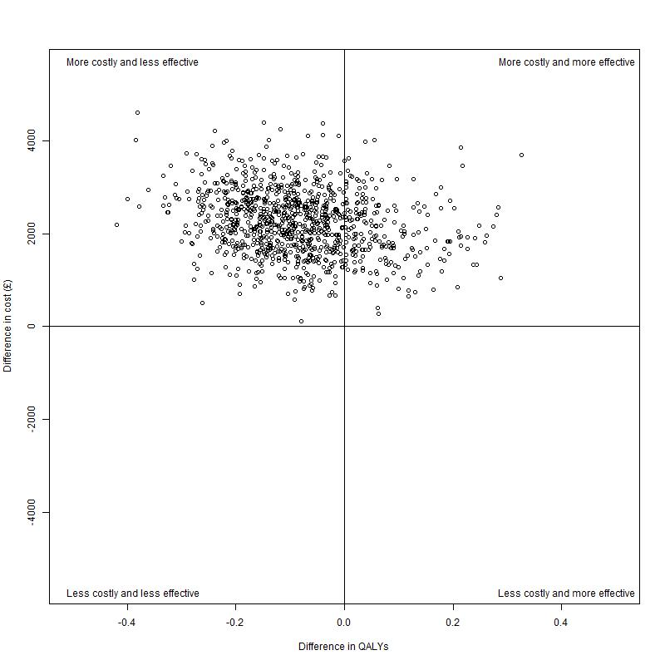 | 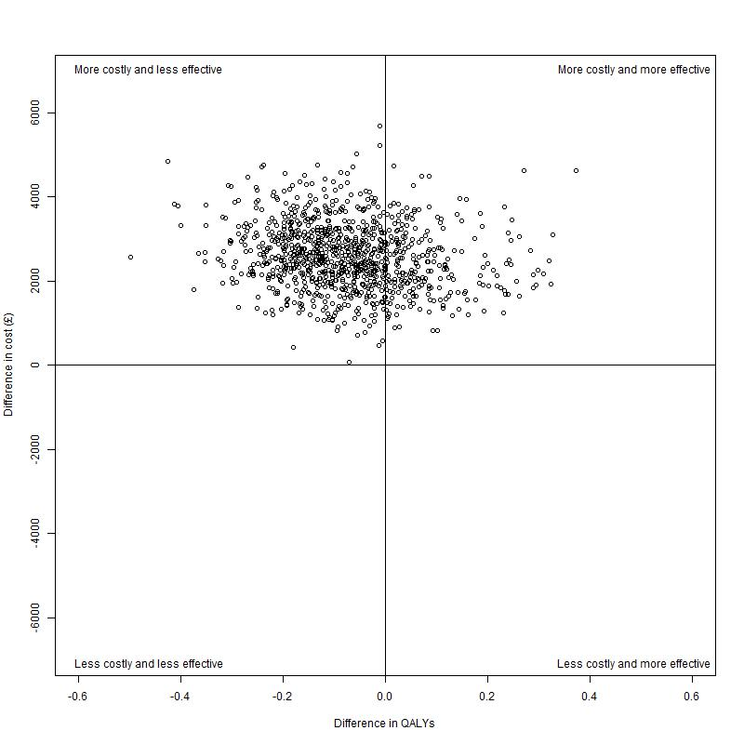
a ) Warfarin, 50 years old, males | b) Warfarin, 50 years old, females

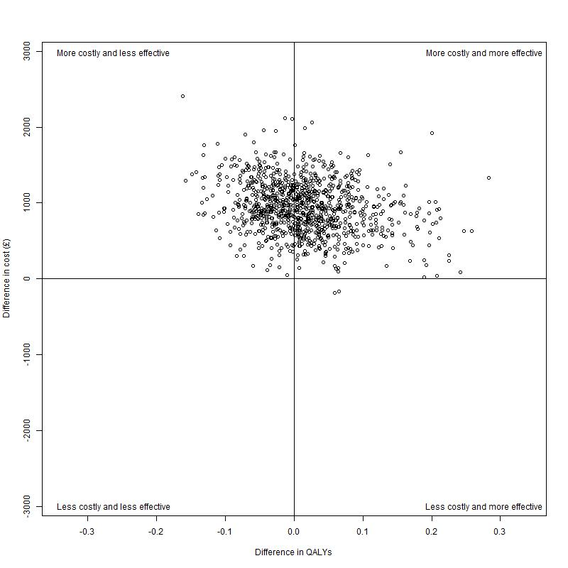 | 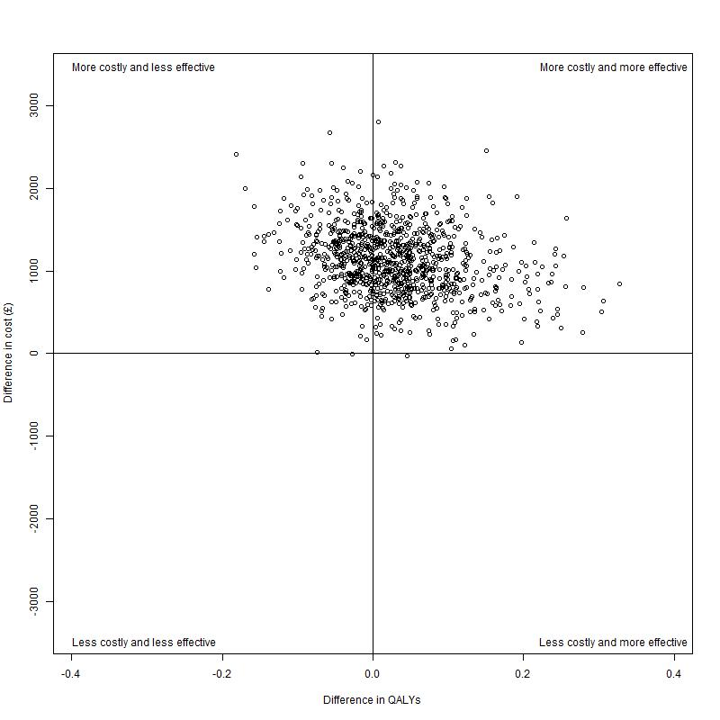
c ) Warfarin, 65 years old, males | d) Warfarin, 65 years old, females

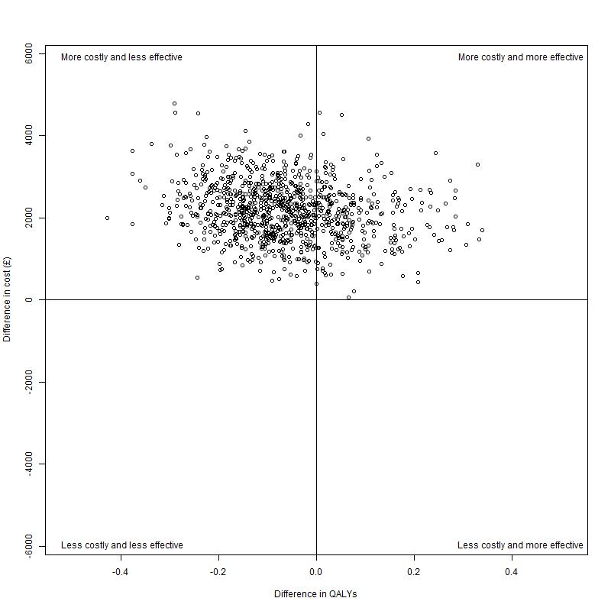 | 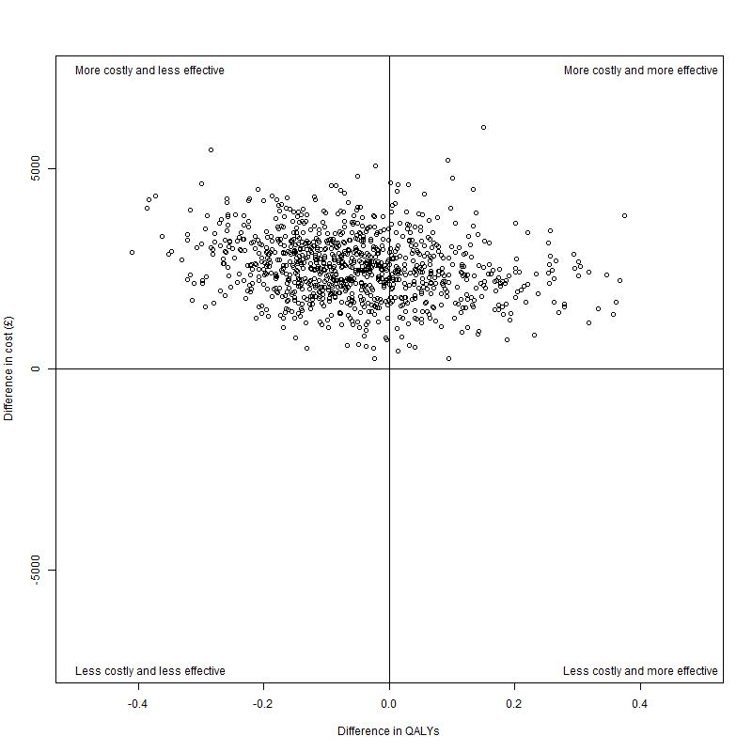
e ) Rivaroxaban, 50 years old, males | f) Rivaroxaban, 50 years old, females

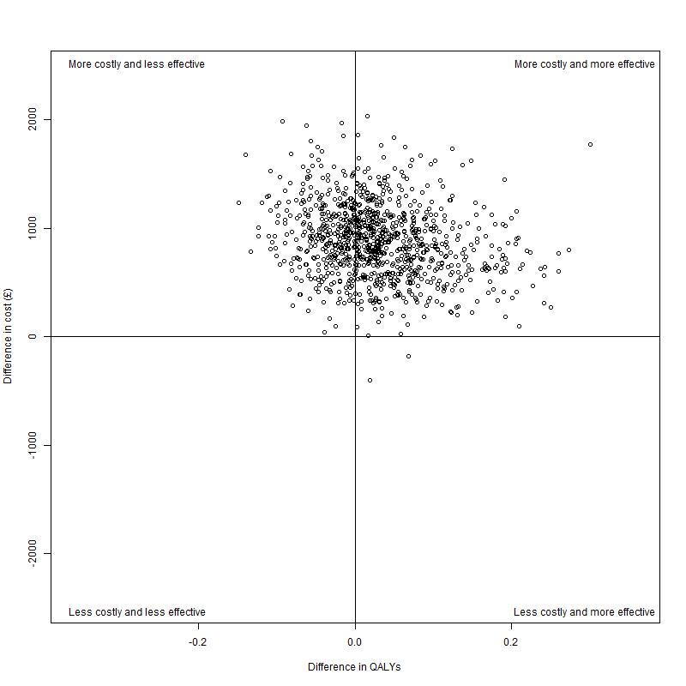 | 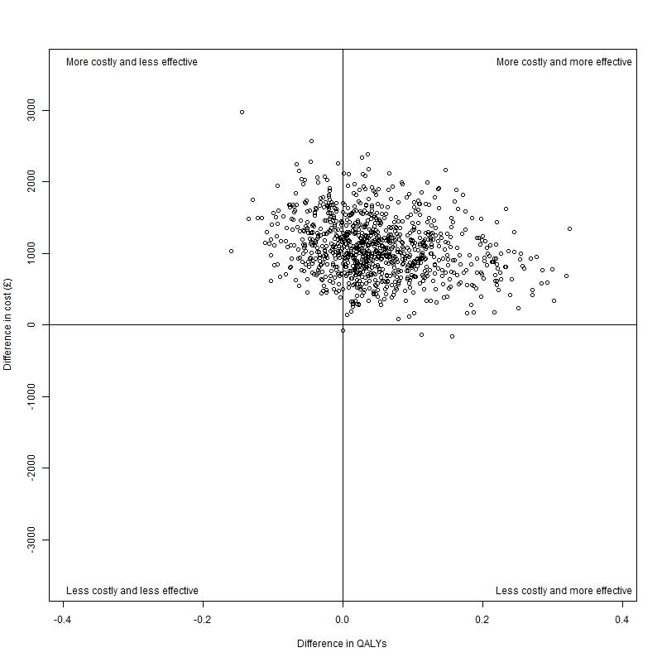
g ) Rivaroxaban, 65 years old, males | h) Rivaroxaban, 65 years old, females

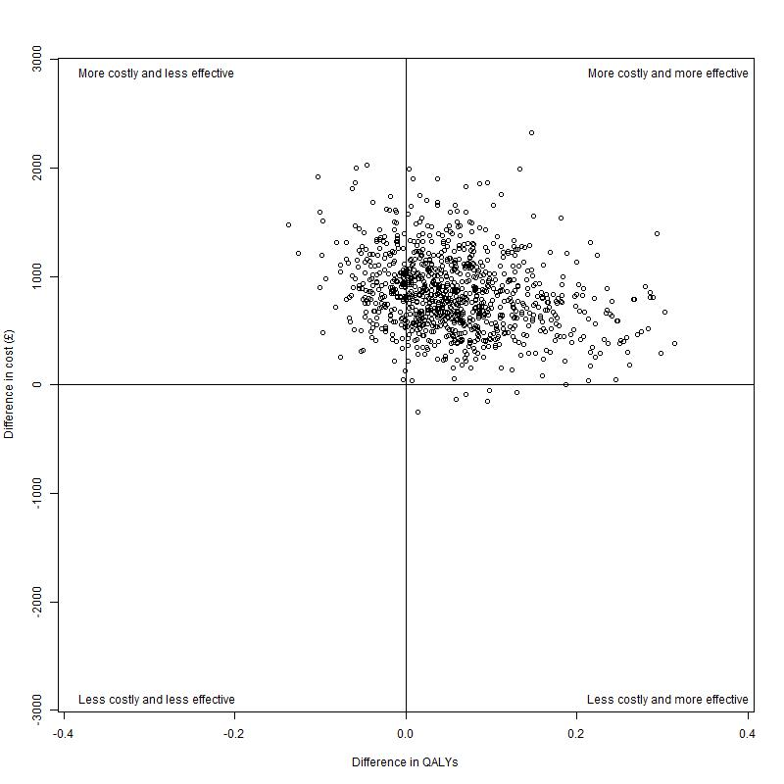 | 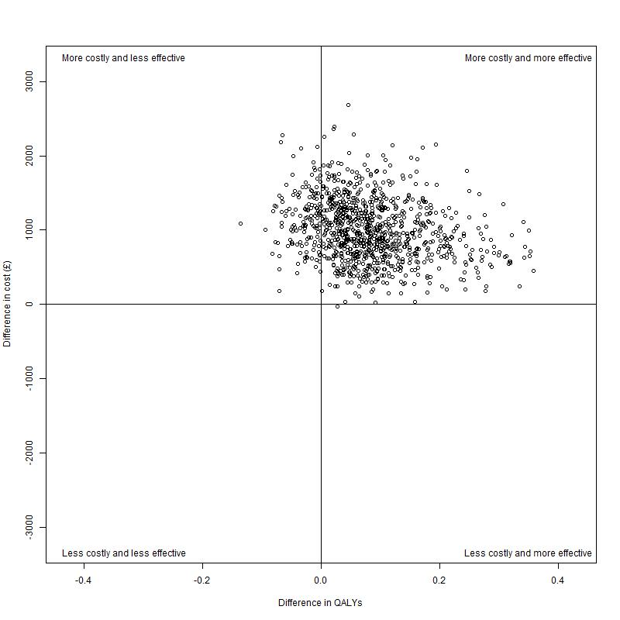
i ) Dabigatran 65 years old, males | j) Dabigatran, 65 years old, females
Table 5 Scatterplots of estimated differences in health outcomes (in QALYs) and cost between the TTE and no TTE strategy for the ten populations simulated. QALY: Quality-adjusted life years. TTE: transthoracic echocardiography

Appendix E: Summary of cost-effectiveness results of TTE compared with no TTE strategies for the 10 patient populations under consideration

OAC | Patient Population | Strategy | Mean Cost (£) | Mean QALY | ICER (95% CrI), £/QALY | TTE dominated?
Warfarin | Male, Aged 50 | No TTE | 2459 | 13.60 | -26 489  (-26 552 to -26 408) | Yes
Warfarin | Male, Aged 50 | TTE | 4712 | 13.51 | -26 489  (-26 552 to -26 408) | Yes
Warfarin | Female, Aged 50 | No TTE | 2815 | 14.27 | -34 078  (-34 175 to -33 952) | Yes
Warfarin | Female, Aged 50 | TTE | 5405 | 14.19 | -34 078  (-34 175 to -33 952) | Yes
Warfarin | Male, Aged 65 | No TTE | 1527 | 9.12 | 66 793  (66 217 to 67 599) | No
Warfarin | Male, Aged 65 | TTE | 2467 | 9.13 | 66 793  (66 217 to 67 599) | No
Warfarin | Female, Aged 65 | No TTE | 1974 | 9.94 | 39 485  (39 291 to 39 754) | No
Warfarin | Female, Aged 65 | TTE | 3106 | 9.97 | 39 485  (39 291 to 39 754) | No
Rivaroxaban | Male, Aged 50 | No TTE | 2449 | 13.61 | -34 060  (-34 170 to -33 910) | Yes
Rivaroxaban | Male, Aged 50 | TTE | 4614 | 13.54 | -34 060  (-34 170 to -33 910) | Yes
Rivaroxaban | Female, Aged 50 | No TTE | 2779 | 14.27 | -47 535  (-47 773 to -47 271) | Yes
Rivaroxaban | Female, Aged 50 | TTE | 5315 | 14.22 | -47 535  (-47 773 to -47 271) | Yes
Rivaroxaban | Male, Aged 65 | No TTE | 1510 | 9.12 | 30 310  (30 179 to 30 487) | No
Rivaroxaban | Male, Aged 65 | TTE | 2393 | 9.15 | 30 310  (30 179 to 30 487) | No
Rivaroxaban | Female, Aged 65 | No TTE | 1955 | 9.95 | 22 751  (22 681 to 22 844) | No
Rivaroxaban | Female, Aged 65 | TTE | 3039 | 9.99 | 22 751  (22 681 to 22 844) | No
Dabigatran | Male, Aged 65 | No TTE | 1487 | 9.13 | 14 728  (14 693 to 14 782) | No
Dabigatran | Male, Aged 65 | TTE | 2321 | 9.18 | 14 728  (14 693 to 14 782) | No
Dabigatran | Female, Aged 65 | No TTE | 1942 | 9.95 | 12 314  (12 290 to 12 348) | No
Dabigatran | Female, Aged 65 | TTE | 2946 | 10.01 | 12 314  (12 290 to 12 348) | No
Table 6 Summary of cost effectivness results. ICER: Incremental cost effectivness ratio. TTE: transthoracic echocardiography; QALY: Quality-adjusted life year. Dominated: the strategy is both more expensive and less effective than the strategy to which it is compared

Appendix F: Cost effectiveness acceptability frontiers

Introduction
This section presents cost-effectiveness acceptability frontiers (CEAFs) of the with- and without-TTE strategies for each of the scenarios presented in appendix D and elsewhere. CEAFs differ from cost-effectiveness acceptability curves (CEACs) as they plot, for each willingness-to-pay threshold, only the option with the highest expected net benefit. They therefore show uncertainty in the adoption decision. As there are only two options (the With TTE Strategy and the Without TTE Strategy) there is no loss of information, as the cost effectiveness of each option is simply the complement of (i.e. one minus) the other option.

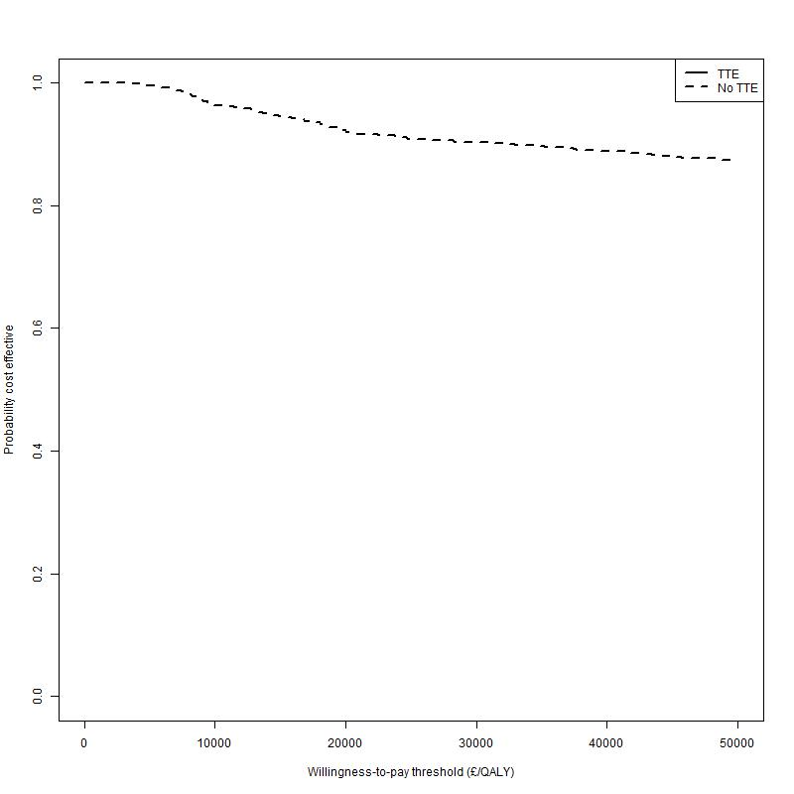 | 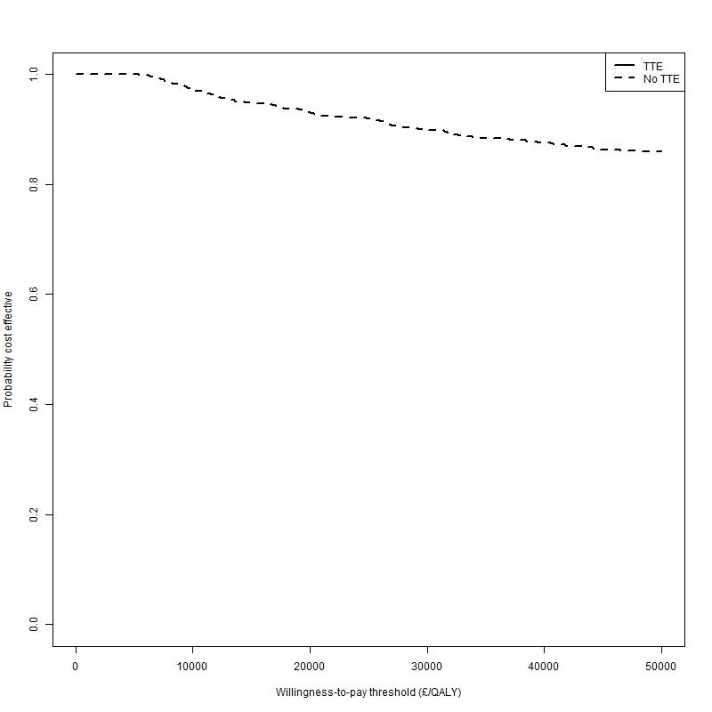
a ) Warfarin, 50 years old, males | b) Warfarin, 50 years old, females

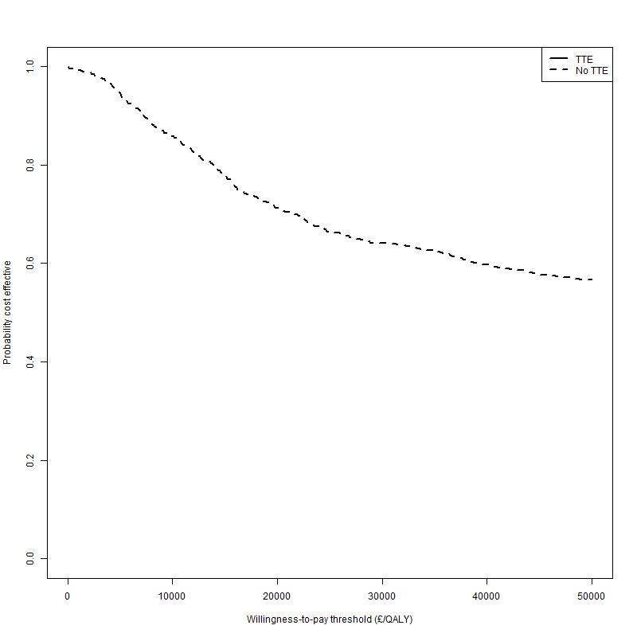 | 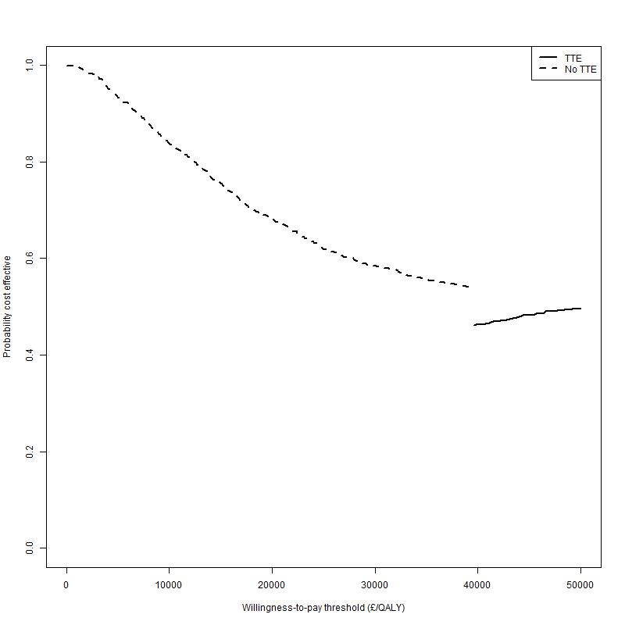
c ) Warfarin, 65 years old, males | d) Warfarin, 65 years old, females

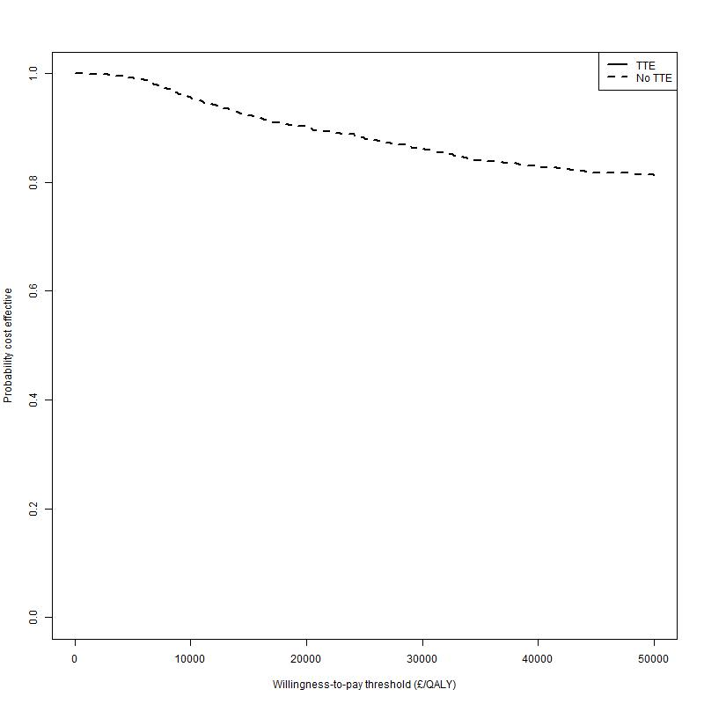 | 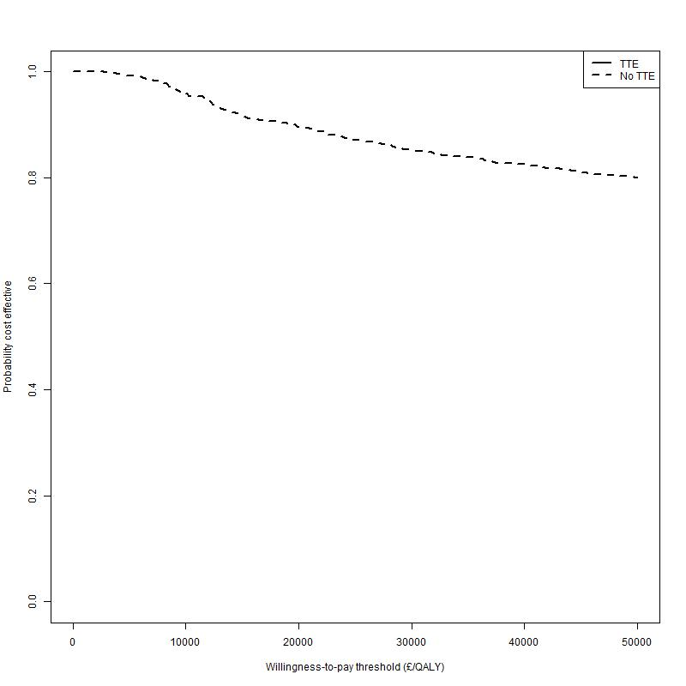
e ) Rivaroxaban, 50 years old, males | f) Rivaroxaban, 50 years old, females

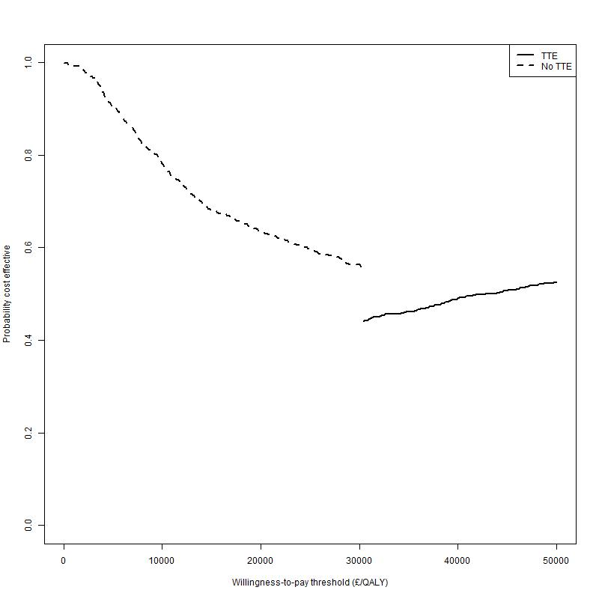 | 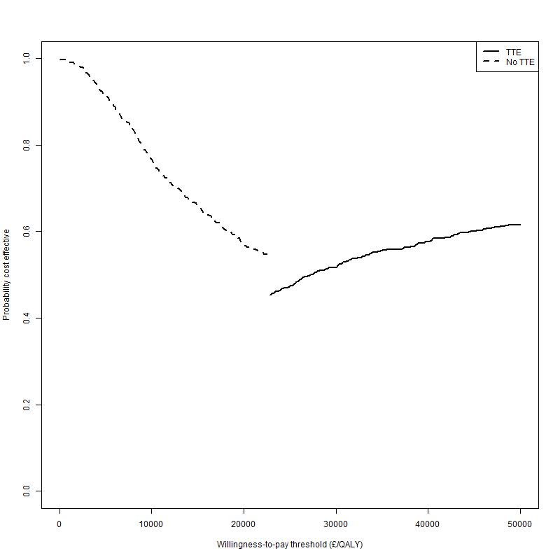
g ) Rivaroxaban, 65 years old, males | h) Rivaroxaban, 65 years old, females

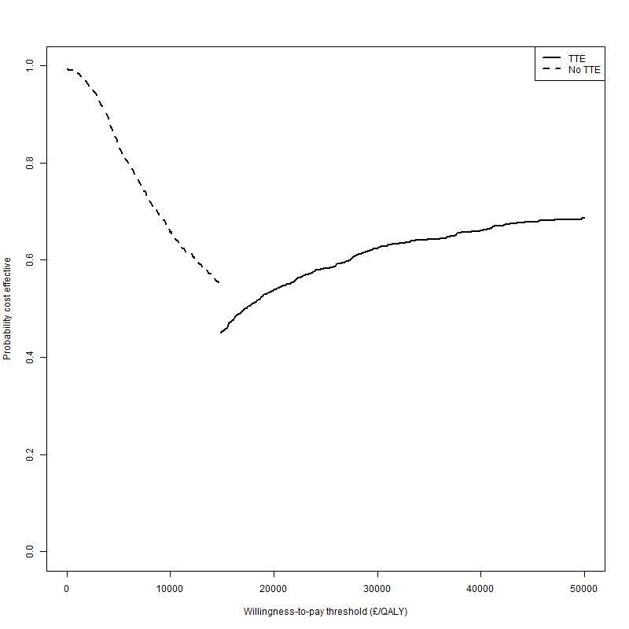 | 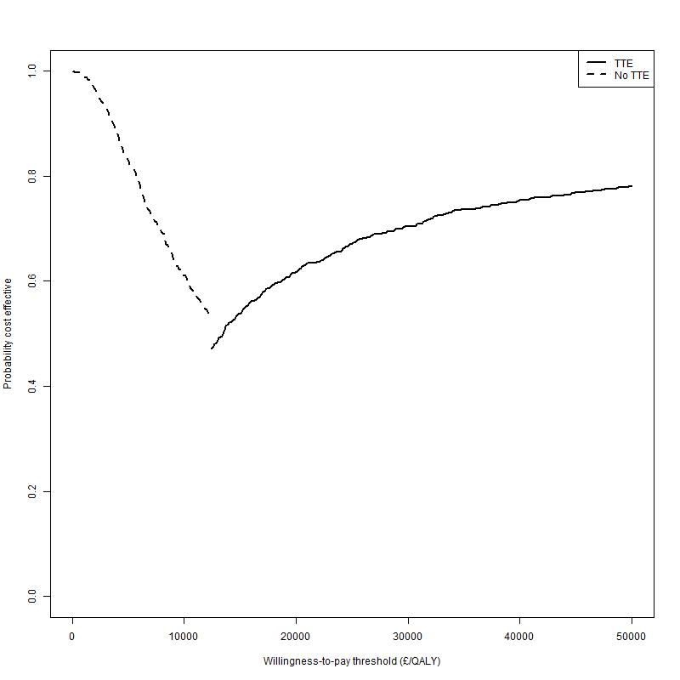
i ) Dabigatran 65 years old, males | j) Dabigatran, 65 years old, females
Table 7 Scatterplots of estimated differences in health outcomes (in QALYs) and cost between the TTE and no TTE strategy for the ten populations simulated. QALY: Quality-adjusted life years. TTE: transthoracic echocardiography

Appendix G: Full Incremental Analyses

Introduction
This appendix presents full incremental analyses, including efficiency frontiers, for the following four patient groups:
- Males, aged 50 years at diagnosis
- Females, aged 50 years at diagnosis
- Males, aged 65 years at diagnosis
- Females, aged 65 years at diagnosis

Males, aged 50 years at diagnosis
The cost-effectiveness plane for this patient group is shown in Figure 1. Of the four strategies evaluated, the No TTE strategy, using Rivaroxaban as the OAC of choice, is estimated to dominate all the other three options.
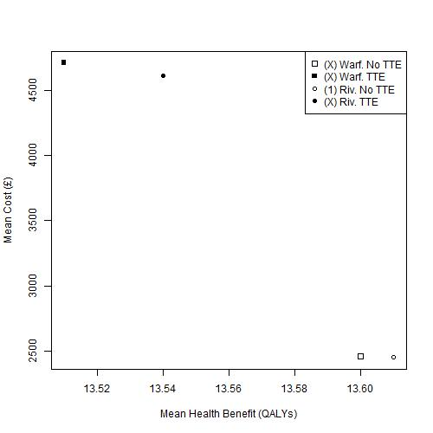
Figure 1 Cost-effectiveness plane of mean costs and mean QALYs for males aged 50 years at diagnosis. Warf: Warfarin; Riv: Rivaroxaban; TTE: Transthoracic Echocardiography

Females, aged 50 years at diagnosis
The cost-effectiveness plane for this patient group is shown in Figure 2. As for males of the same age, of the four strategies evaluated, the No TTE strategy, using Rivaroxaban as the OAC of choice, is estimated to dominate all the other three options. However, the differences in estimated cost and QALY benefit between this option and the No TTE strategy using Warfarin as the OAC of choice are extremely small.
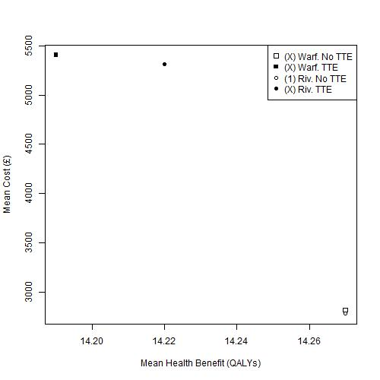
Figure 2 Cost-effectiveness plane of mean costs and mean QALYs for females aged 50 years at diagnosis. Warf: Warfarin; Riv: Rivaroxaban; TTE: Transthoracic Echocardiography

Males, aged 65 years at diagnosis
The cost-effectiveness plane for this patient group is shown in Figure 3. Of the six strategies evaluated, the No TTE strategy using dabigatran as the OAC of choice (Dab, No TTE) is estimated to be the lowest cost option, and so forms the start of the efficiency frontier. The equivalent TTE strategy (Dab, TTE) forms the next and final part of the efficiency frontier, with an ICER, compared with Dab, No TTE, of £14 728 / QALY, as shown in Appendix E. All other options are ruled out by simple or extended dominance.
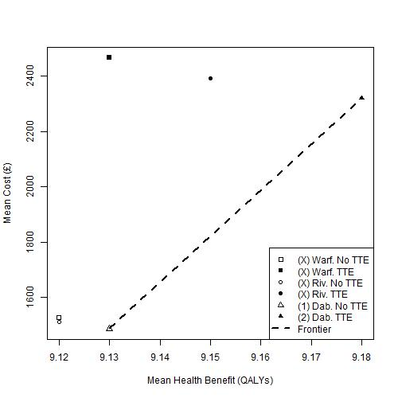
Figure 3 Cost-effectiveness plane of mean costs and mean QALYs for males aged 65 years at diagnosis. Warf: Warfarin; Riv: Rivaroxaban; Dab: Dabigatran; TTE: Transthoracic Echocardiography

Females, aged 65 years at diagnosis
The cost-effectiveness plane for this patient group is shown in Figure 4. As for males of the same age, of the six strategies evaluated, the strategy Dab, No TTE is estimated to be the cheapest, and so forms the start of the efficiency frontier. The next and final option in the frontier is the strategy Dab, TTE, with an ICER of £12 314 / QALY, as shown in Appendix E. All other options are estimated to be ruled out by simple or extended dominance. However, the absolute differences in costs and QALYs between the Riv. No TTE and Dab. No TTE options are extremely small.
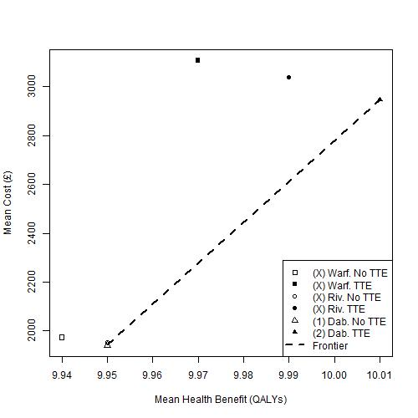
Figure 4 Cost-effectiveness plane of mean costs and mean QALYs for females aged 65 years at diagnosis. Warf: Warfarin; Riv: Rivaroxaban; Dab: Dabigatran; TTE: Transthoracic Echocardiography

Appendix H: Additional Exploratory Analysis – the relationship between true prevalence of LAABN and mean ICER

Introduction
This appendix illustrates how the ICER of the TTE with the No TTE strategies change, for each of the four patient groups, and each of the OACs, as a function of the estimated proportion of the patients with LA ABN, here defined as true proportion high risk (TPHR). In this sensitivity analysis, TPHR is varied between 0 and 20%.
As before, it is assumed that the OACs to be considered are warfarin and rivaroxaban for persons aged 50 years at diagnosis; and warfarin, rivaroxaban and dabigatran for person aged 65 years at diagnosis.
It is seen in all analyses (Figure 5 to Figure 8) that higher estimates of TPHR lead to lower ICERs and so greater cost-effectiveness of using TTE for the OAC decision at any given willingness to pay threshold. It is also seen that the rank order of the cost-effectiveness of each OAC is preserved; i.e. that at any TPHR, rivaroxaban has a lower ICER than warfarin in persons aged 50 at diagnosis, and dabigatran is estimated to have the lowest ICER in persons aged 65 at diagnosis.

Persons aged 50 years at diagnosis
Figure 5 shows how the mean ICER varies for males aged 50 years at diagnosis; Figure 6 presents the equivalent estimates for females. Gender has a smaller influence on the relationship between TPHR and ICER than the OAC assumed to be prescribed if the feature were identified. Where warfarin is assumed to be the OAC of choice, using TTE in this way is not estimated to be cost-effective at a high willingness-to-pay threshold of £30,000/QALY. By contrast, the ICER of TTE is estimated to be below £30,000/QALY when rivaroxaban is assumed to be the OAC prescribed following a positive identification
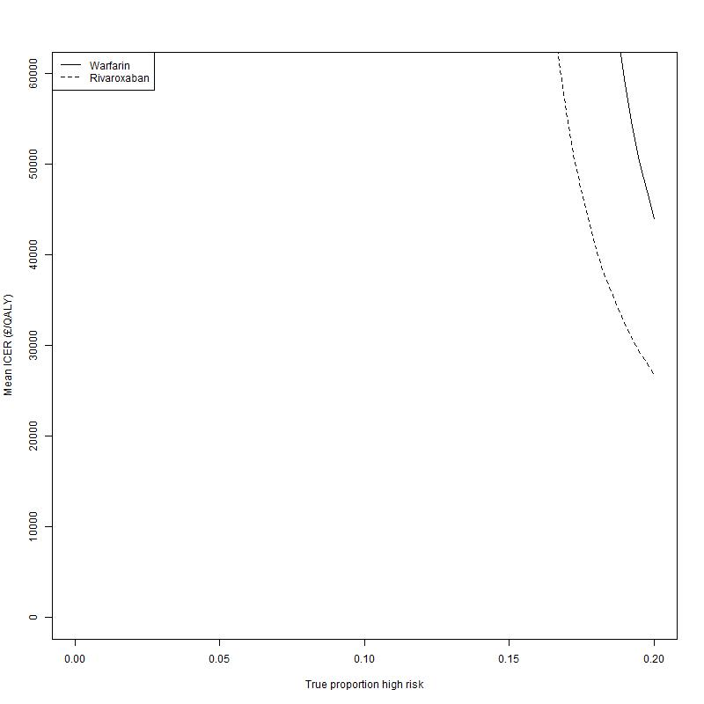
Figure 5 Relationship between mean ICER and True Proportion High Risk (TPHR) for males aged 50 years at diagnosis, if either warfarin or rivaroxaban was the OAC of choice

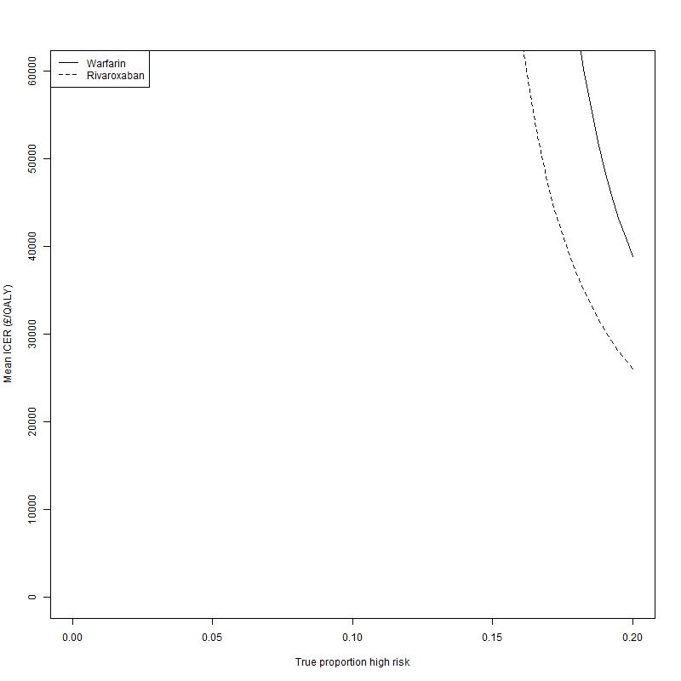
Figure 6 Relationship between mean ICER and True Proportion High Risk (TPHR) for females aged 50 years at diagnosis, if either warfarin or rivaroxaban was the OAC of choice

Persons aged 65 years at diagnosis
Figure 7 shows how the mean ICER varies for males aged 65 years at diagnosis; Figure 8 presents the equivalent estimates for females. Dabigatran is now assumed to be an option for these patient groups, and uses of TTE involving dabigatran are estimated to have lower ICERs regardless of the TPHR level assumed. At higher TPHR estimates, the differences in ICERs in TTE strategies involving different OAC options decreases, and is substantially below £20,000/QALY regardless of OAC assumed. As with the scenarios involving persons diagnosed at the aged of 50 years, the OAC assumed appears to have much greater effect on estimated cost effectiveness than gender.

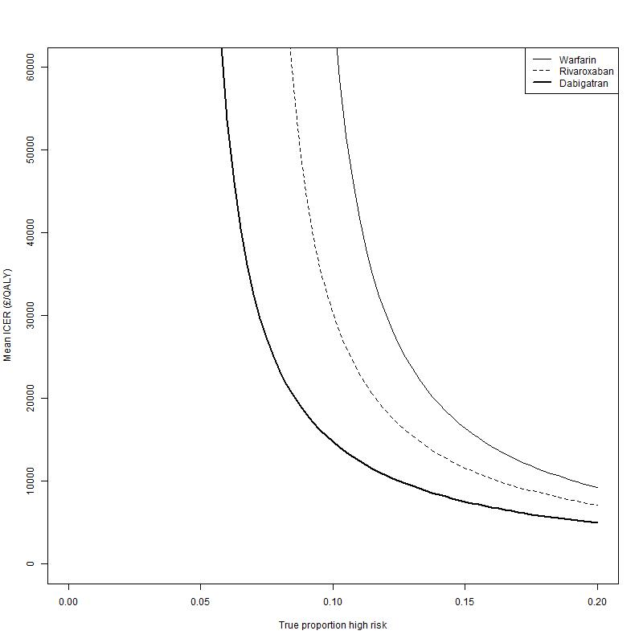
Figure 7 Relationship between mean ICER and true proportion high risk (TPHR) for males aged 50 years at diagnosis, if either warfarin, dabigatran or rivaroxaban was the OAC of choice

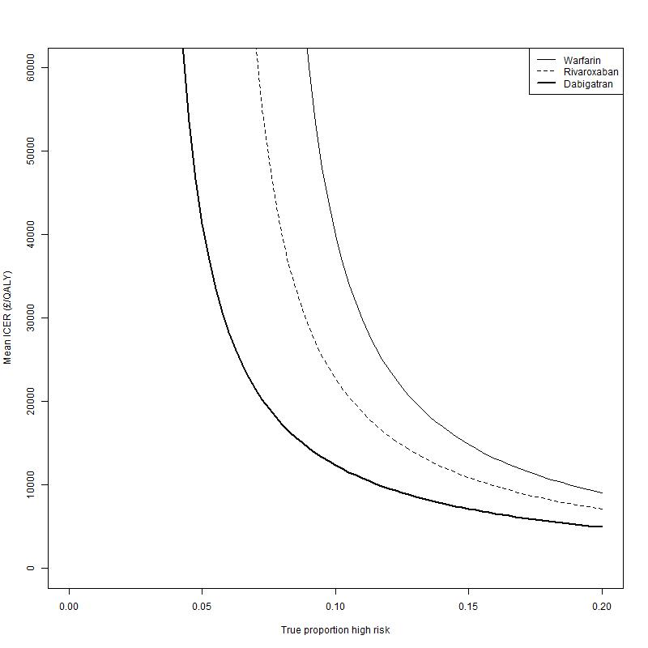
Figure 8 Relationship between mean ICER and True Proportion High Risk (TPHR) for females aged 65 years at diagnosis, if either warfarin, dabigatran or rivaroxaban was the OAC of choice

